SKILL AND JOB RECOMMENDER PNT2022TMID07494

**Setting up Application Environment**

**Create Flask Project**

|  |  |
| --- | --- |
| Date | 31 October 2022 |
| Team ID | PNT2022TMID0S7494 |
| Project Name | Skill/Job Recommender Application |

**Step 1.** Install Python latest version from python.org and while installing the file check the .exe option.

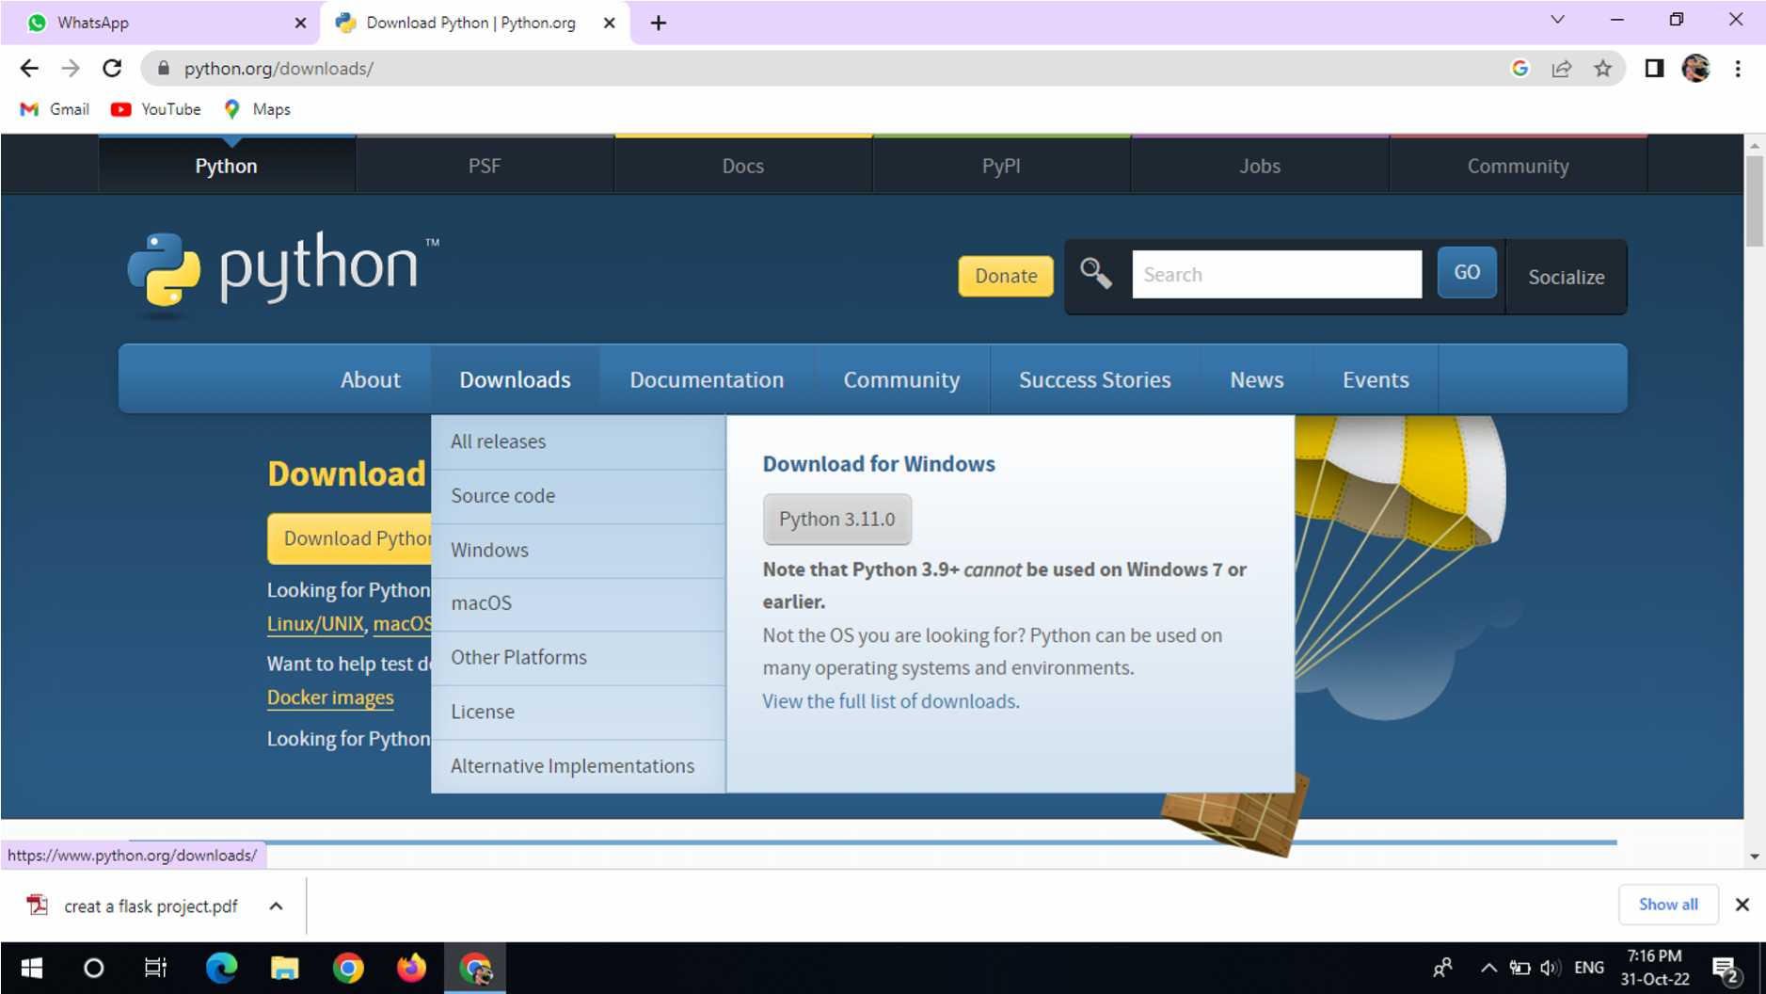

**Step 2**.Install Flask using command → ***pip install flask*** 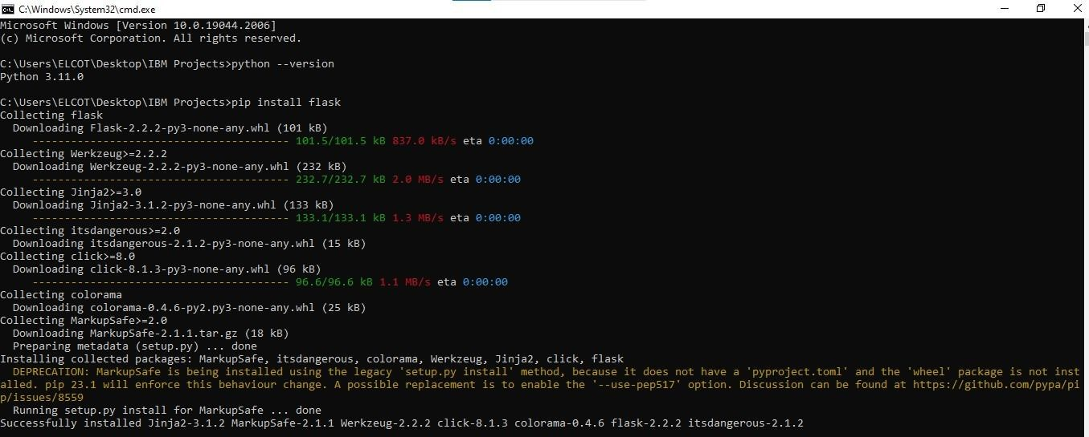

**Step 4**.Open Visual Studio Code and start coding:

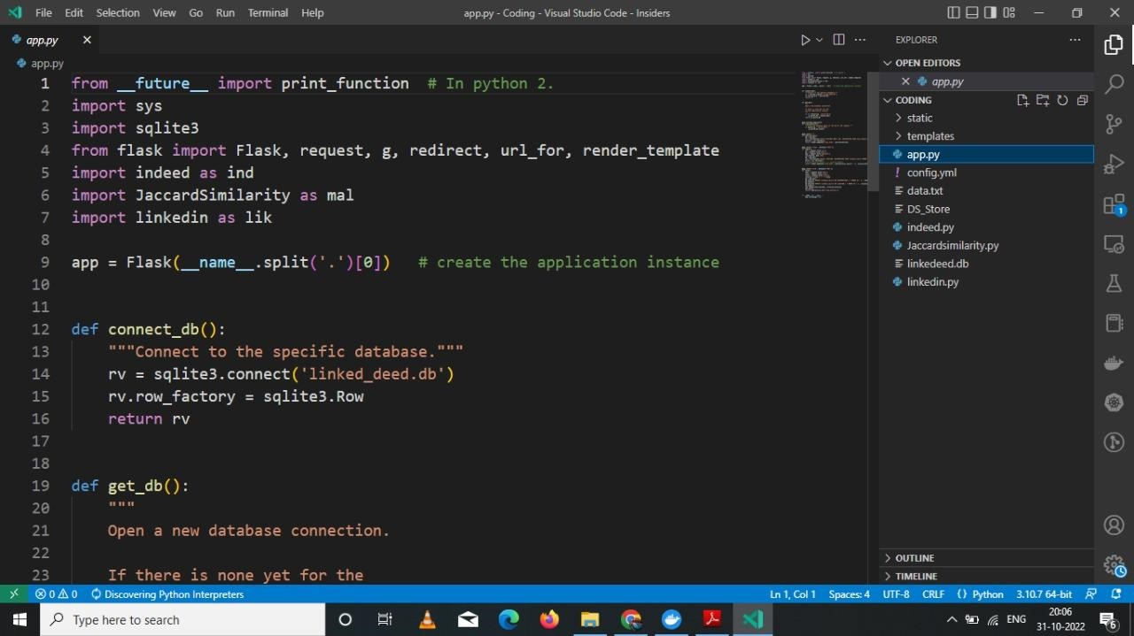

**Step 5**. Save the code give the file name as app.py

**Step 6**: Go to the file location and open the command prompt - type the command → ***flask run***

**Step 7 :** Click the link or copy the address ***(http://127.0.0.1:5000/)*** then put into the any browser and click enter after that output will show in our screen: 